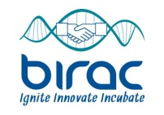
BIRAC SEED Fund at Venture Center, Pune - Round 2 Now Open!
Attention Technology Entrepreneurs
BIRAC SEED Fund at Venture Center aims to provide technology driven start-ups, with special focus on biotec/biomed, with much needed early stage financial support for deserving ideas/technologies.
The seed fund is now accepting investment proposals as part of Round 2
*Application deadline is 4th Sept 2017
*Details on evaluation criteria, typical investment amounts, equity stakes, deal terms, application form, business plan templates, etc. are all available here: http://www.venturecenter.co.in/birac_seed.php.

