Press release: 12 May 2016

Pune, 12 May 2016

Pune-based Venture Center receives National Award for Technology Business Incubation

Venture Center (also called the Entrepreneurship Development Center), the technology business incubator hosted by the CSIR-National Chemical Laboratory, Pune, has received the National Award for Technology Business Incubation for this year. The award was received by Dr V Premnath, Director, Venture Center and Head, NCL Innovations, CSIR-NCL, at the hands of the Honorable President of India, Shri Pranab Mukherjee, on 11 May 2016 at Vigyan Bhawan, Delhi during the National Technology Day celebrations
Venture Center team is delighted to receive the National Award. This award acknowledges the efforts and initiatives of the Venture Center team and board members - past and present, incubatees, host institute CSIR-NCL and all the numerous people contributing to enrich Venture Center's innovation ecosystem as mentors, speakers, reviewers, committee members etc. .
Venture Center has the distinction of helping create several spin-off companies from publicly funded research labs in India and wishes to create a first of its kind, world class ecosystem for inventive enterprises for India

Photos:
1) Dr V Premnath receiving the National Award for Technology Business Incubator 2015 by the Honorable President of India, Shri Pranab Mukherjee, on 11 May 2016 at Vigyan Bhawan, Delhi on the occasion of National Technology Day.
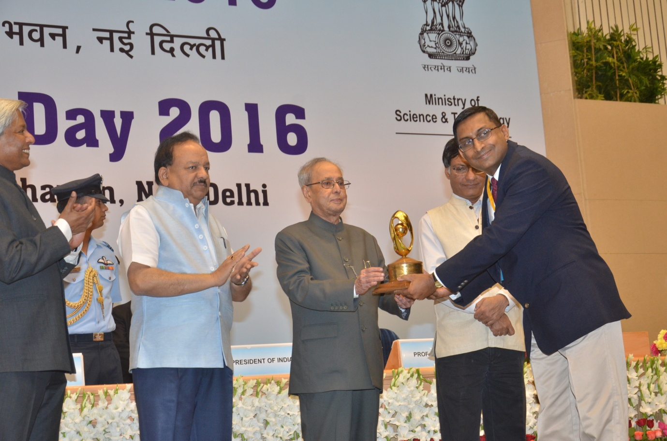

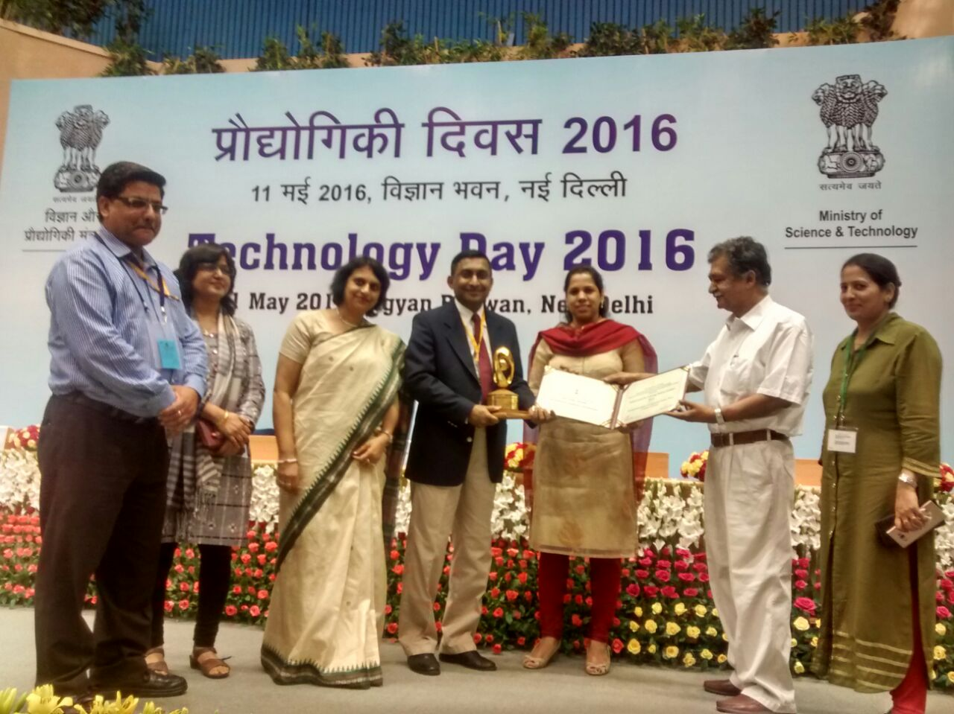

2) The proud VC team with the National Award
