29 Dec 2016

Venture Center achieves accreditation for desirable norms (highest category) by Credibility Alliance

Venture Center (officially registered as Entrepreneurship Development Center) has been formally been informed by Credibility Alliance (CA) that it has been Accredited under Desirable Norms – the highest level of accreditation offered by CA. This accreditation provides an independent, respected and credible recognition of the high standards of accountability, transparency and governance followed by Venture Center. The accreditation positions Venture Center as the only technology business incubator in India with CA accreditation. The accreditation will not only help open several new opportunities for Venture Center but also position Venture Center as a benchmark in India amongst non-profit incubators for good governance practices.

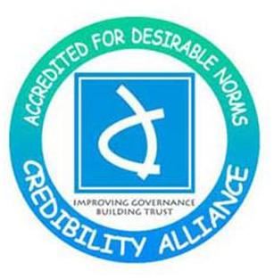

Credibility Alliance is a consortium of Voluntary Organizations (VOs) committed towards enhancing Accountability and Transparency in the Voluntary Sector through good Governance. Registered in May 2004 as an independent, not-for-profit Organization, CA emerged as an initiative from within the Sector. The Organization was formed after an extensive consultative process over a period of two years involving more than 500 VOs all over India. As an Organization, CA aspires to build trust among all stakeholders through improving Governance and accountable practices within the Voluntary Sector. Credibility Alliance is akin to a professional body that set Norms or Standards of Governance.

The accreditation process involved detailed submissions and review of information, a site visit and meetings with various functionaries and beneficiaries.

Websites:
- http://www.credibilityalliance.org/
- http://www.credibilityalliance.org/pdf/About-Credibility-Alliance.pdf
- http://www.venturecenter.co.in/aboutus.php

